Technical rider 2020
Jazz Orchestra of the Concertgebouw

Any questions regarding technical issues can be directed to:
Koert Berends
info@kobe-audio.com
+31 6 508 06 449

Any questions regarding other production issues can be directed to:
Hilde Slinger
hilde.slinger@jazzorchestra.nl
+31 70 360 24 96

Sound system
A professional sound system that is capable of delivering a clear, undistorted sound in every area of the venue should be ready for use when the orchestra technician arrives.
Preferred brands are L-Acoustics or D&B.

Mixing Console
A 32ch inputs/ 12 outputs professional digital mixing console should be ready and working on arrival of the orchestra technician. Preferred deskbrands are Digico (SD-series), Allen&Heath (SQ 6/7) , Midas (Pro-series) or Yamaha (CL series). If the venue does not have a digital desk of this size/capabilities please contact the orchestra technician for a suitable solution.

Important note: please setup the front of house desk in the middle of the hall. Not on the side

Monitors
6 full-range, undistorted monitorwedges should be available on arrival of the orchestra technician. These monitors should all be connected to a separate mixgroup to which audio can be send. Preferred monitor types are: L-Acoustics X12 , D&B M4

Monitor Groups
- Vocals (double pair of monitor speakers)
- Piano
- Drums
- Bass
- Solo spot
- Side fill for horn section

Channellist

Notes:
The mics on the list are preferred examples. Suitable replacements with similar characteristics are also okay. Please provide us with professional mics as replacements. A list of these replacements mailed to the technician is greatly appreciated.

The number of channels is depended on the particular program and size of the room. Please get in touch with our technician beforehand to find out if a reduced channellist is sufficient for the concert in your venue.

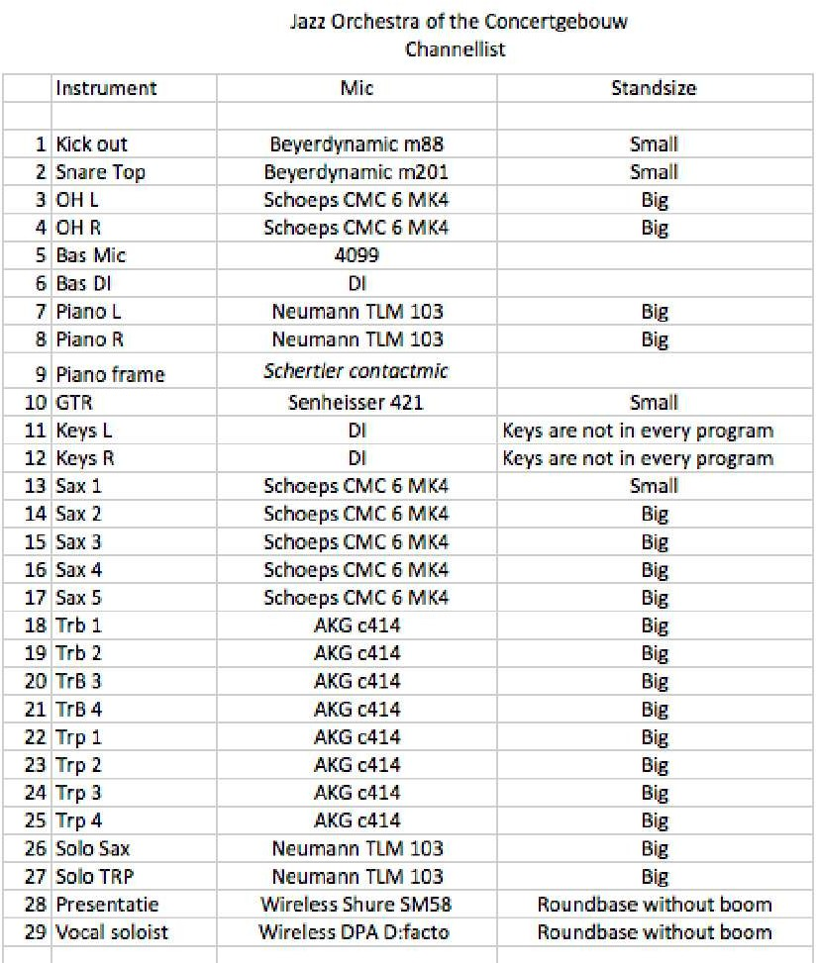

Stageplot

Notes:
The trombones and trumpets should be on a riser of 4x3 meters. The height of this platform should be 40 cm.

Every musician except for drums, bass and conductor (they demand two) should have one music stand placed in front of them.

On stage we will need 9 armless chairs for the saxophones and trombones and 5 barstools for the trumpets and guitarplayer. These notes are also implemented in the next section of the rider.

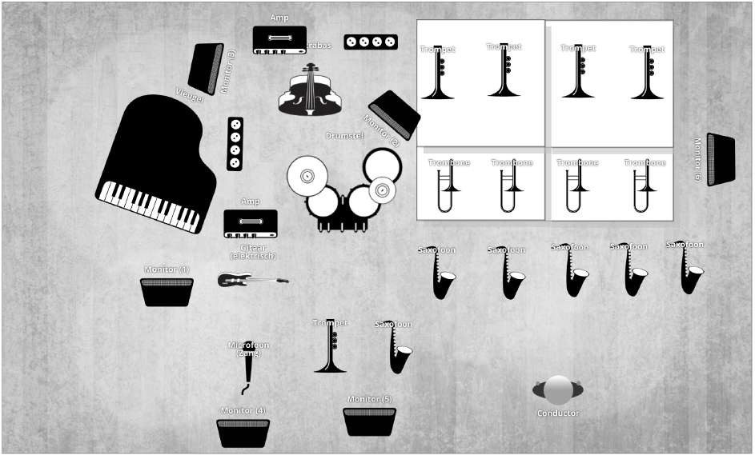

On Stage

Required backline
- Drum kit: Jazz Drum set (3 cymbal stands)
18 inch Bass drum
14 inch snare drum
12 inch tom
14 inch floor tom
Drums hardware (bass drum pedal , hi-hat stand, 3 cymbal stands
Drum chair
Drum carpet
- Guitar amp: Fender Twin (reissue)
- Double bass amp: Gallien Krueger MB150S
- Grand piano: Steinway D, tuned at 442 hz

Required on stage
- 1 riser (4x3 meters, 40 cm in height)
- 9 chairs without arms
- 5 barstools
- 18 music stands
- 23 lights for these music stands (we will bring 5 stands our self)
- 25 bottles of water

Lights
A theatrical light set with dynamic as well as moving light is required for a great performance. We trust on the professional opinion and experience of the venues own lighting technician to make us look good.

